Leader Overview
Volume Overview
Believe Boldly
The gospel message is shocking to many, shocking because of its implications. God has made himself known to us and promised to place His Spirit into our heart. We have been given direct access to Him. The Bible encourages us to come to Him with boldness. Our boldness in approaching Him is not from our words or our achievements. Instead, it’s based on God’s promises. So we ask, remembering His power and faithfulness. And we encourage those around us to do the same. Believe boldly.
Session Overview
Declare His Promise
In this Live session, kids will discover that we can trust God in any situation we’re facing. When times are challenging or uncertain, we can call on God and rest in the Bible’s promises about who He is. Kids will look at the example of Paul, who faced a life-threatening storm at sea. This story shows us how to hold tight to our faith and encourage others in trying times.
Bible Lesson
Paul Proclaims God’s Protection through a Storm
Acts 27:1, 7–11, 20–26, 30–44
Faith Fact
I will hold tight to Jesus.
Faith Verse
1 Corinthians 16:13–14 (NLT)
Be on guard. Stand firm in the faith. Be courageous. Be strong. And do everything with love.

Preparing for the Session
Leader Preparation Time: 20–25 Minutes
You Will Need
Large Group
- Bible
- Worship songs (Song suggestions: “Nothing Is Impossible” Lyric Video by Planetshakers; “10,000 Armies” by Influence Music; “Way Maker” Lyric Video by Leeland; “Do It Again” by Elevation Worship)
- For groups not using a phone or tablet only, add:
• Projector or TV
• Laptop
• Countdown60 Video–60 seconds
• Faith Fact Slide
• Faith Verse Video or Slide
• Bible Lesson Video
• Teaching Point Slides 1–3
- Building blocks, forty or more
- Two soft balls
- Five large disposable plastic cups
- Three large cardboard boxes
Small Group
- Building blocks (from Large Group Game)
- Bibles for kids in the group to share
- Small Group Faith Verse Review, one per kid
- Pencils, one per kid
- Small Group Activity Page, one per kid
- Pencils or pens, one per kid
- Crayons or markers

To access session content and videos from a computer, visit: BibleEngagementProject.com/downloads

Getting Ready
Large Group
- Download videos and slides if needed.
- Select worship song(s) and have them ready to play.
- Read the Bible Lesson Scripture to prepare for Teaching Time.
- Label the large cardboard boxes with a phrase (Boldly Share, Boldly Lead, Boldly Encourage).
Small Group
- Print copies of the Small Group Faith Verse Review, one per kid.
- Print copies of the Small Group Activity Page, one per kid.

First time leading Live for Kids? Check out the Facilitator Guide.

Large Group
30 Minutes
See what’s needed at the beginning of the session.

Introduction
Hey, everyone! Today’s going to be a great day. Show me two thumbs up if you agree. (Group response) Today we’ll discover how knowing who God is makes us brave, strong, and bold no matter what.
Have you ever had a close call? Maybe you faced a dangerous situation, but somehow you didn’t get hurt. Raise your hand if that has happened to you. (Group response)
• Share a personal story of a dangerous (but not too scary) situation that turned out okay because God protected you.
Isn’t it amazing how our life can change in one moment? That might cause some people to worry about the future. (Show the Bible.) But when we follow Jesus and hold tight to Him, we can have peace and know that He will be with us and can take care of us.
Faith Fact
That reminds me of our Faith Fact for today: I will hold tight to Jesus. In our Bible story, we’re going to see how Paul held tight to Jesus in a very scary situation.
• Show the Faith Fact Slide.
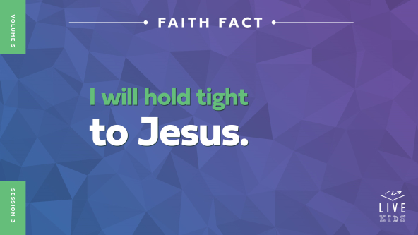
Sometimes it can be hard to hold tight to Jesus. You might even be wondering what that means. After all, how can we hold tight to Someone we can’t see with our eyes or feel with our hands? Well, holding tight to Jesus means trusting Him with all your heart whether things are good or bad in your life. It means you believe His words are true, He loves you, and He will take care of you. No matter what’s going on, Jesus will help you get through.
Everyone, flex your arms and say the Faith Fact with me. I will hold tight to Jesus. One more time: I will hold tight to Jesus. Well done!

Game
Power Tower
Let’s play a game called Power Tower! I need three boys and three girls who are ready to give it their all.
• Choose the volunteers for the game.
Here’s how the game works. Each team will build the tallest tower they can before the sixty seconds are up. But the clock will be paused along the way. When that happens, the builders will step back and one person on each team gets to attack the other team’s tower by throwing a ball at it. When the clock starts again, the team can keep on building. The team with the taller standing tower when time is up wins the game.
• Start the Countdown60 Video, pausing every fifteen seconds or so to let each team attack the other team’s tower.

• Make sure that you have the teams throw the ball from a good distance, so they really must aim well.
• Play again if you have time.
Wow! Great job, everyone! Did you notice how easy it was to knock over or damage the towers? (Group response) Sometimes it can feel like our own life gets messed up that quickly. After just one or two bad days, it can feel like everything is toppling over. But when that happens, we need to remember that Jesus is with us! Let’s say the Faith Fact together as a reminder. I will hold tight to Jesus.

Worship
Something that can help us hold tight to Jesus is worship. When we worship Him, especially during difficult times, we remember how good Jesus is and how much we need Him. Then it’s a no-brainer to hold tight to Jesus. Who’s ready to worship Jesus right now? (Group response) One way to worship Jesus is by singing. Let’s worship Him together.
• Lead the kids in singing one or two praise songs. See suggestions at the beginning of the session.

Bible Lesson
Thanks for worshipping Jesus with me! You can worship no matter where you are or what you’re doing. We’ll see what the Bible says about some people who really needed Jesus in the middle of their desperate situation. But first let’s pray.
Prayer
Dear Jesus, thank You for giving us this opportunity to learn more about You from the Bible. Help us understand that You are good even when we’re struggling or worried. We can trust Your promises and know You will take care of us. In Your name, we pray. Amen.
Video Intro
Just before we look at the Bible story, let’s watch this video.
• Play Bible Lesson Video.
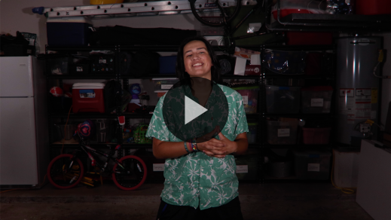
Bible Story
Paul Proclaims God’s Protection through a Storm
Have you ever been in a situation like Dash where things kept going wrong? (Group response) Dash had to trust that God would take care of him and work things out, even though Dash could have done something sneaky to get what he needed. In the Bible, Paul also had to trust that God would take care of him. Let’s take a closer look at the Bible story Dash was talking about.
Teaching Time
In our Bible story, Paul was a prisoner even though he hadn’t done anything wrong. He had been sent to prison for sharing the good news of Jesus. How do you think Paul felt about being put in prison unfairly? (Allow responses.) Surprisingly, he didn’t seem too upset about the situation. Paul was willing to go through hard things if it meant he could tell people about Jesus.
A Roman officer named Julius was taking Paul and some other prisoners to court in the big city of Rome. Paul wanted to go to Rome. God had told him that he would share the good news of Jesus with the people there. That story happened a few chapters earlier in Acts. But Paul was in prison in Caesarea, and traveling to Rome meant sailing across the Mediterranean Sea. Let’s find out if Paul showed the people around him how to live out our Faith Fact. Say it with me. I will hold tight to Jesus.
Grab your Bible or pull up a Bible app on your device. Turn to Acts 27. We’re going to read several verses in this chapter. (1, 7–11, 20–26, 30–44)
• In order to keep Large Group time moving along, we recommend that the leader reads the Scripture portions aloud.
• Optional: Remind the kids to mark this place with a bookmark, so they can read it on their own at home.
1. Paul warned the crew.
• Show the Teaching Point 1 Slide.
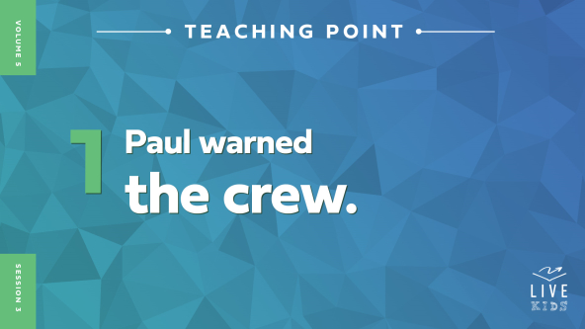
• Read Acts 27:1, 7–11.
Back in Bible times, people couldn’t just hop on a plane or drive a car to travel long distances. So instead, Paul, the Roman soldiers, and the other prisoners got on a boat to sail to Rome. Did you notice the Bible story used the word we a lot? (Group response) That’s because Luke, the author of the Book of Acts, was on the boat with Paul too. In fact, Luke often traveled with Paul.
Journeys like this one were dangerous and expensive. Paul told the people in charge of the ship that they shouldn’t try to cross the sea when the weather was bad. They could lose cargo, the ship might sink, and they might even die! But no one wanted to listen to Paul. Why do you think they didn’t listen to him? (Allow responses.)
Remember Paul was just a prisoner to the crew. Maybe they thought he didn’t know what he was talking about. After all, Paul hadn’t been a ship’s captain before. Or maybe they didn’t want to lose money by slowing down. But it would have been a good idea for the officers of the ship and the sailors to listen to Paul.
I wonder if God showed Paul what was about to happen. Maybe God was getting Paul ready to lead the people through what was coming. No matter what, Paul trusted God, which meant he could do bold things. How else would a prisoner feel bold enough to tell the ship’s officers what to do? Paul had a solid foundation of holding tight to Jesus. It’s kind of like this.
• Hold up a plastic cup.
See this cup? It works great to hold a drink. But what would happen if you started putting weight on it?
• Begin to crush the cup.
It can become damaged or even crushed. I think we need a stronger foundation.
• Place four cups upside down on the floor to fit under the corners of the first box.
Living for Jesus means being bold in different ways. Paul was bold as he shared wisdom to help the crew keep people on the ship safe.
• Grab the box labeled “Boldly Share,” and set it on the cups.
Being that bold can be a heavy responsibility. Without a strong foundation, it might make us feel wobbly and uncertain in our faith. But if we hold tight to Jesus like Paul did, we have a strong foundation. Let’s keep reading to see what Paul did next.
2. Paul encouraged the crew.
• Show the Teaching Point 2 Slide.
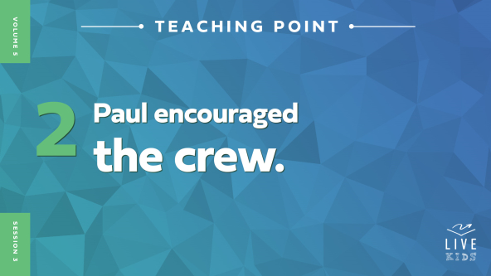
• Read Acts 27:20–26.
Hold up! Everyone was hungry and the terrible storm kept raging and the ship was going to sink—but everyone was going to be okay? That’s a lot of scary news and some really good news! But the crew must have wondered how it was all going to happen. They had been in this storm for days and days. They had tied ropes around the ship so it wouldn’t break apart in the waves. They had thrown some supplies overboard so the ship wouldn’t turn over. They were trying to save what little food was left, so no one had eaten for days. How do you think they felt? (Allow responses.) I think they were hungry, terrified, and worn out.
Then Paul told them he had a message from one of God’s angels: The ship would sink, but everyone was going to be safe. How do you think the crew and the other prisoners reacted to what Paul said? (Allow responses.)
Paul wasn’t afraid to encourage the crew, no matter how unbelievable his message sounded. He knew what God’s messenger had told him, and he was holding tight to Jesus.
• Place the box labeled “Boldly Lead” on top of the first box.
Leading other people, like Paul did, can make us feel a lot of pressure sometimes—especially if we don’t have a firm foundation. But Paul had faith in what God had said and believed God would be with them, no matter what happened next.
3. The crew listened to Paul, and everyone survived.
• Show the Teaching Point 3 Slide.
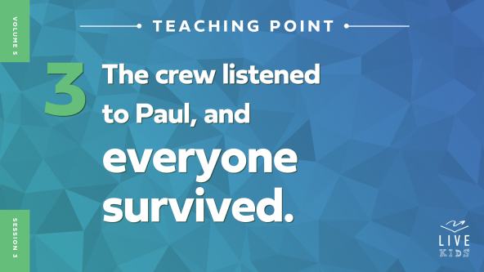
• Read Acts 27:30–44.
Did you hear the amazing details in this story? Paul told the sailors not to use the lifeboat! That’s one thing you usually need to be safe on a ship in an emergency. Did they follow Paul’s instruction? (Group response) Yes, they did.
As night was ending, Paul told everyone to eat and build up their strength. Then the crew decided to steer the ship toward the land. But the ship hit ground too soon and started breaking into pieces! Would you have wanted to be on that ship? (Group response) What do you think the other 275 people on the ship were thinking about Paul now? (Allow responses.)
Everyone had to really trust Paul to follow the instructions God had given him. Paul was leading them in some ways that didn’t make sense, but Paul was trusting Someone much smarter: God! Paul obeyed God, and everything went according to His plan—even if that meant a shipwreck. I wonder if Paul ever had trouble holding tight to Jesus during the voyage. Do you think he wondered at least a little bit if they would all die at sea? (Allow responses.)
Paul showed us another layer of trusting God and building on a firm foundation.
• Grab the box labeled “Boldly Believe,” and place it on top of the two other boxes.
For Paul to boldly share, boldly lead, and boldly believe, he needed to hold tight to Jesus. Otherwise, he’d have a weak foundation—and so would we. It would be like removing a cup or two from our base. What do you think would happen if we did that? (Allow responses.) Let’s find out.
• Remove a cup, so the tower falls.
• Rebuild the tower as you continue.
(Set up the cups.) If we have a strong foundation, then we can do what God wants us to do. We can boldly share, boldly lead, and boldly believe. (Stack up boxes.) It’s not about being perfect, knowing all the right answers, or proving how good we are. It’s about trusting God and staying close to Him. We can make it through every hard time when He is with us.
Remember our Faith Fact: I will hold tight to Jesus. God truly knows what He is doing, and He will take care of us. He is always good, and we always need Him. So let’s hold tight to Jesus.

Prayer and Response
Consider playing a worship song softly in the background while kids pray.
Paul showed us how to hold tight to Jesus even when things got really scary and uncertain. Maybe you’re going through something right now that feels that way. Here’s a question to think about as we pray together: What are you going through right now that makes you want to hold tight to Jesus?
Let’s take some time to be quiet. Close your eyes and listen quietly for the Holy Spirit to speak to you as you think about your answer to that question. I’ll say it one more time: What are you going through right now that makes you want to hold tight to Jesus? If it’s not easy to think of your answer, ask yourself: Is there something in my life that makes me scared or nervous? Let’s ask God to help us hold tight to Jesus in these areas.
• Give kids a few minutes to pray quietly.
Prayer
Optional: Have the kids repeat phrases of the prayer after you.
Dear God, thank You for being my strong foundation. I know I can always trust and believe in You. Help me see how to hold tight to You no matter what I’m facing. When it’s hard and when it’s easy, help me have faith in You. In Jesus’ name. Amen.
Faith Verse
Our Faith Verse is all about being bold and courageous. This is a great reminder as we hold tight to Jesus in hard times.
• Play Faith Verse Video.
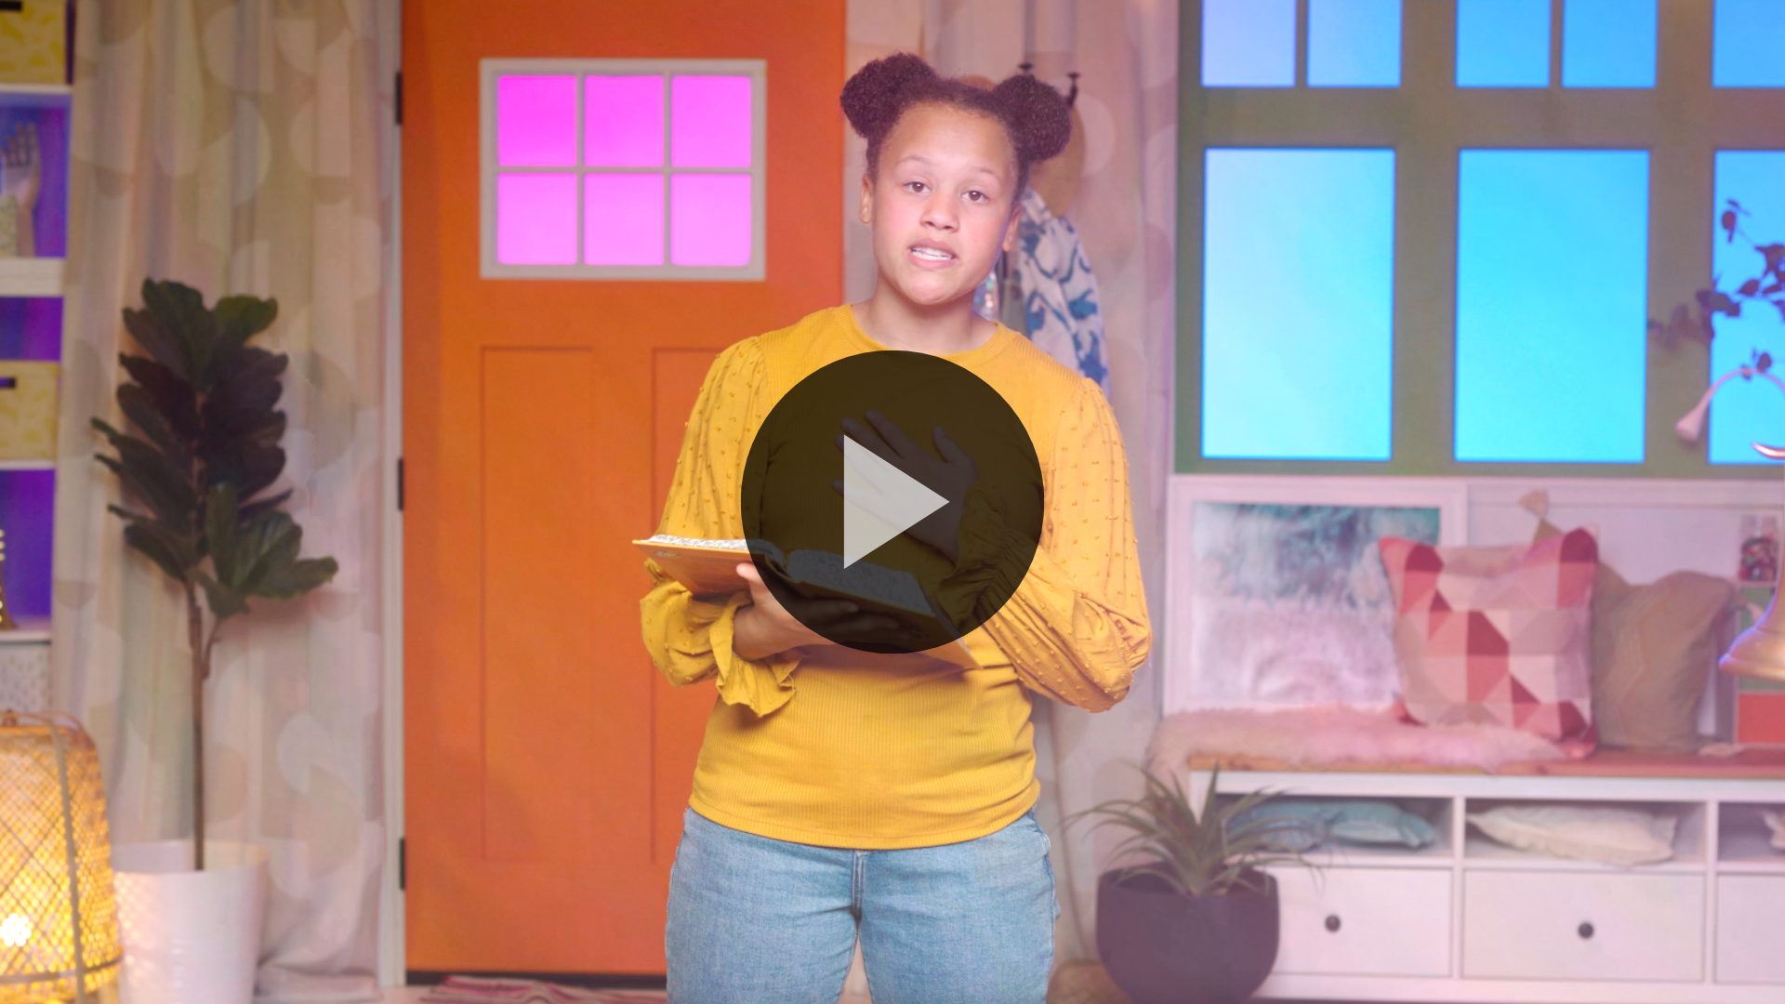
1 Corinthians 16:13–14 (NLT)
Be on guard. Stand firm in the faith. Be courageous. Be strong. And do everything with love.
Let’s say the Faith Verse in a high-pitched voice. (Group response) Now let’s say it one more time in a low-pitched voice. (Group response) Great job!
Faith Fact
Before we move on, let’s review our Faith Fact. I will hold tight to Jesus.
• Show the Faith Fact Slide.
Let’s say the Faith Fact together. First, wrap your arms around yourself in a big hug. I will hold tight to Jesus. Now flex your arms, and let’s say it again, I will hold tight to Jesus.
• Dismiss kids to Small Group time or to go home if your group time ends here.

Small Group
30 Minutes
This section can be done in conjunction with the large group or on its own if you do small groups with your kids. During Small Group time, the goal is to connect the kids with the Word of God and to each other. All activities are led by the small group leader.

Group Connection
Story Stack
You Will Need
- Building blocks (from Large Group Game)

No prep is needed for this activity.
In our Bible story today, we talked about what it means to hold tight to Jesus, even if we were lost at sea for weeks and then our ship crashed. When we have a firm foundation in Jesus, we can stay steady and strong no matter what happens.
We’re going to do an activity that will help us learn a little bit about each other. I want you to share about a time you needed to hold tight to Jesus. For example, Paul might say, “One time I was on a ship when a terrible storm came. It lasted for weeks! Everyone thought our boat was going to sink, and we’d all die. But we made it safely to shore. God kept us safe.”
Try to share quickly. Then after your turn, you’ll add one block to our tower. Let’s see how tall we can build it as we remember times we needed Jesus!
• Share first to give kids an example of what you’d like them to tell the group.
• Take turns allowing each kid to share. Repeat as time allows.
Thanks for sharing those stories, everyone! Paul showed us that when we hold tight to Jesus, we have a firm foundation. We can remember that the next time we face difficult times like the ones we just talked about.

Bible Lesson Recap
• If small group activities are not immediately following large group time, you may want to read the Bible story passage before the discussion.
You Will Need
- Bibles for kids in the group to share

No prep needed for this activity.
Bible Story Review: Paul Proclaims God’s Protection through a Storm
Acts 27:1, 7–11, 20–26, 30–44
What was the most interesting thing about the Bible story we heard today? (Allow responses.) Those are great answers! To review, Paul was being taken to Rome on a ship as a prisoner. He warned the crew about bad sailing conditions, but they didn’t listen. While they were sailing, a strong storm hit. After they were stuck at sea, Paul got a message from God that they would all survive. The crew listened to Paul’s instructions, and sure enough, everyone made it. What a story!
Why was it important that Paul held tight to Jesus? (Allow responses.) When we know how good Jesus is and how much we need Him, holding tight to Him just makes sense! But in this story, Paul’s faith helped everyone else on board trust God too.
• Give each kid a Bible and read the Bible story together.

Group Discussion
Feel free to use all or just a few questions as a jumping-off place for good discussion. Questions marked with * are designed for more conversation. Adjust the questions based on the age or maturity of your group. Typically, older kids will be able to dive a little deeper than younger ones.
Questions
Where was Paul sailing? Why was he sailing there?
Do you think most Romans believed in God? Why do you think that?
* How do you think you would feel if you were on the boat in that storm?
What did Paul say would happen if the sailors tried to escape on the lifeboat?
Would it be easy or hard to follow what Paul said to do? Why?
How do you think the sailors were different after their shipwreck?
* When have you needed to really hold tight to Jesus?
* What happens when we go through hard things if we don’t have a firm foundation?
* How can we hold tight to Jesus today?

Live It
Faith Fact
Our Faith Fact today is I will hold tight to Jesus. Paul showed the prisoners and sailors on the ship how to do that. Jesus makes us strong enough to help others through tough situations too. We all need to learn how to hold tight to Jesus every day.
Challenge
This week’s challenge is to look for ways to get close to Jesus. That’s how we hold tight to Him! Maybe you can start praying before going to bed every night. Just tell God about the good and bad parts of your day and ask for His help. Maybe you can start reading more about Jesus in the Bible and learn more about how He cares for you. Pick one of these things to do this week, and watch what happens when Jesus is your strong foundation.
Prayer
Finish group discussion by sharing prayer requests and praise reports. Keep track of your small group’s prayer requests and review them each time you meet.
• Have kids share and pray for each other’s prayer requests.
Dear Jesus, thank You for being a strong foundation we can trust. Help us get to know You more, so we stay strong and steady in every situation we face. In Your name we pray. Amen.

Faith Verse Review
You Will Need
- Small Group Faith Verse Review, one per kid
- Pencils, one per kid
Getting Ready
- Print copies of the Small Group Faith Verse Review, one per kid.
Our Faith Verse is 1 Corinthians 16:13–14. God wants us to do everything in love and become stronger and stronger in our faith. Let’s go over it together!
• Show Faith Verse Video.
1 Corinthians 16:13–14 (NLT)
Be on guard. Stand firm in the faith. Be courageous. Be strong. And do everything with love.
Living with courage means knowing that Jesus won’t ever let us down. We can trust Him, even when it seems hard. Let’s review our Faith Verse as a group a few more times. Try to memorize it as best as you can, because you’ll need to know it for the game.
• Say the verse as a group a couple of times.
Faith Verse Fun
Draw It
All right, now it’s time to test your knowledge of the Faith Verse. Each of you will get a page with some of the verse words on it. Your assignment is to replace some of the words with pictures. Try to think of images or shapes you can use to replace words, like a heart for the word love. Get creative, and see what you can come up with!
• Hand out a copy of the Small Group Faith Verse Review and a pencil to each kid. Give kids time to complete the activity.
Great job, everyone! Memorizing this Faith Verse will help us remember some important ways to hold tight to Jesus.

Activity Page
Hidden Pictures
You Will Need
- Small Group Activity Page, one per kid
- Pencils or pens, one per kid
- Crayons or markers
Getting Ready
- Print copies of the Small Group Activity Page, one per kid.

Our Faith Fact is I will hold tight to Jesus. When Paul and the others listened to God, they had to trust Him enough to believe they’d be safe. They also got rid of things that weighed down the ship. Let’s see if you can find things that don’t belong in this picture of our Bible story.
• Hand out a copy of the Small Group Activity Page, a pencil, and crayons to each kid.
When you’ve found all the hidden objects, color the picture. Imagine what it must have been like to be with Paul and the others in that storm!

Dismissal
Remember, God wants us to be close to Him. When we follow Jesus and obey God’s Word, we have a strong foundation for bold faith. God’s love give us courage!
Prayer
Dear God, please help us to become closer to You. Help us to pray more, read more of Your Word, and worship You in every way. We love You so much. Help us to choose You as our solid foundation. In Jesus’ name. Amen.
Faith Fact Recap
• Show the Faith Fact Slide.
Remember, God doesn’t just want me or someone else to live with bold faith. He wants you to be courageous and hold tight to Jesus too! Let’s say the Faith Fact together. I will hold tight to Jesus. I’m so glad you came today. I can’t wait to see you next time.
• Send home the Small Group Activity Page and Small Group Faith Verse Review Page.
• Remind parents that there are Family Devotions available on the app to do with their kid.
• Tell everyone the date and time for the next session.

